**WEEK 3: SPRING CORE AND MAVEN**

**Exercise 1: Configuring a Basic Spring Application**

**Scenario:**

Your company is developing a web application for managing a library. You need to use the Spring Framework to handle the backend operations.

**Pom.xml**

<project xmlns="http://maven.apache.org/POM/4.0.0"

xmlns:xsi="http://www.w3.org/2001/XMLSchema-instance"

xsi:schemaLocation="http://maven.apache.org/POM/4.0.0

http://maven.apache.org/xsd/maven-4.0.0.xsd">

<modelVersion>4.0.0</modelVersion>

<groupId>com.library</groupId>

<artifactId>LibraryManagement</artifactId>

<version>1.0-SNAPSHOT</version>

<properties>

<maven.compiler.source>1.8</maven.compiler.source>

<maven.compiler.target>1.8</maven.compiler.target>

</properties>

<dependencies>

<dependency>

<groupId>org.springframework</groupId>

<artifactId>spring-context</artifactId>

<version>5.3.36</version>

</dependency>

</dependencies>

<build>

<plugins>

<plugin>

<groupId>org.codehaus.mojo</groupId>

<artifactId>exec-maven-plugin</artifactId>

<version>3.1.0</version>

<configuration>

<mainClass>com.library.MainApp</mainClass>

</configuration>

</plugin>

</plugins>

</build>

</project>

**BookRepository.java**

package com.library.repository;

public class BookRepository {

public void save(String book) {

System.*out*.println("Saving book: " + book);

}

}

**BookService.java**

package com.library.service;

import com.library.repository.BookRepository;

public class BookService {

private BookRepository bookRepository;

public void setBookRepository(BookRepository bookRepository) {

this.bookRepository = bookRepository;

}

public void addBook(String book) {

bookRepository.save(book);

}

}

**applicationContext.xml**

<?xml version="1.0" encoding="UTF-8"?>

<beans xmlns="http://www.springframework.org/schema/beans"

xmlns:xsi="http://www.w3.org/2001/XMLSchema-instance"

xsi:schemaLocation="

http://www.springframework.org/schema/beans

http://www.springframework.org/schema/beans/spring-beans.xsd">

<bean id="bookRepository" class="com.library.repository.BookRepository"/>

<bean id="bookService" class="com.library.service.BookService">

<property name="bookRepository" ref="bookRepository"/>

</bean>

</beans>

**MainApp.java**

package com.library;

import com.library.service.BookService;

import org.springframework.context.ApplicationContext;

import org.springframework.context.support.ClassPathXmlApplicationContext;

public class MainApp {

public static void main(String[] args) {

ApplicationContext context =

new ClassPathXmlApplicationContext("applicationContext.xml");

BookService service = (BookService) context.getBean("bookService");

service.addBook("The Great Gatsby");

}

}

**Output:**

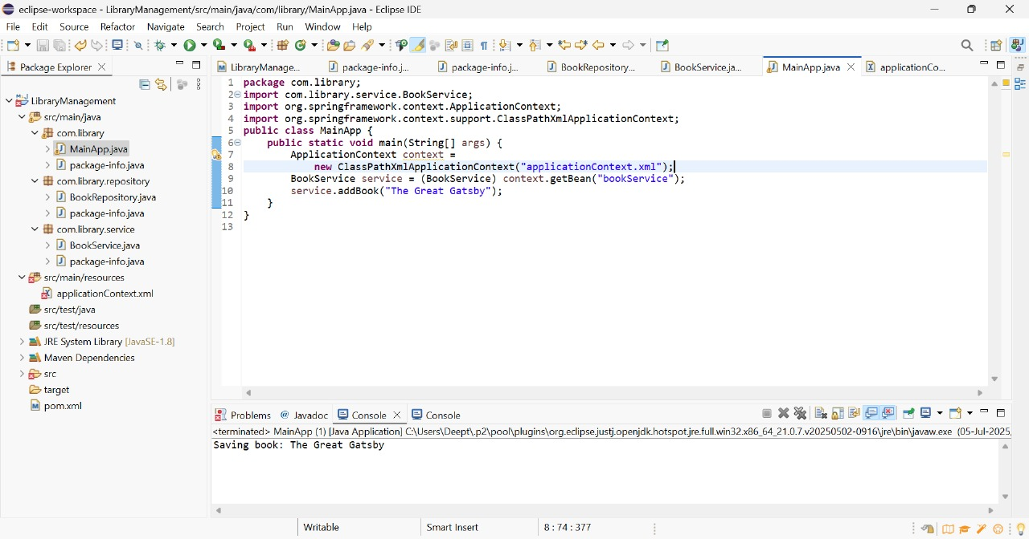

**Exercise 2: Implementing Dependency Injection**

**Scenario:**

In the library management application, you need to manage the dependencies between the BookService and BookRepository classes using Spring's IoC and DI.

**Code:**

**POM.xml**

<project xmlns="http://maven.apache.org/POM/4.0.0"

xmlns:xsi="http://www.w3.org/2001/XMLSchema-instance"

xsi:schemaLocation="http://maven.apache.org/POM/4.0.0

http://maven.apache.org/xsd/maven-4.0.0.xsd">

<modelVersion>4.0.0</modelVersion>

<groupId>com.library</groupId>

<artifactId>LibraryManagement</artifactId>

<version>1.0-SNAPSHOT</version>

<properties>

<maven.compiler.source>1.8</maven.compiler.source>

<maven.compiler.target>1.8</maven.compiler.target>

</properties>

<dependencies>

<dependency>

<groupId>org.springframework</groupId>

<artifactId>spring-context</artifactId>

<version>5.3.36</version>

</dependency>

</dependencies>

<build>

<plugins>

<plugin>

<groupId>org.codehaus.mojo</groupId>

<artifactId>exec-maven-plugin</artifactId>

<version>3.1.0</version>

<configuration>

<mainClass>com.library.MainApp</mainClass>

</configuration>

</plugin>

</plugins>

</build>

</project>

**BookRepository.java**

package com.library.repository;

public class BookRepository {

public void save(String book) {

System.*out*.println("Saving book: " + book);

}

}

**BookService.java**

package com.library.service;

import com.library.repository.BookRepository;

public class BookService {

private BookRepository bookRepository;

public void setBookRepository(BookRepository bookRepository) {

this.bookRepository = bookRepository;

}

public void addBook(String book) {

bookRepository.save(book);

}

}

**applicationContext.xml**

<?xml version="1.0" encoding="UTF-8"?>

<beans xmlns="http://www.springframework.org/schema/beans"

xmlns:xsi="http://www.w3.org/2001/XMLSchema-instance"

xsi:schemaLocation="

http://www.springframework.org/schema/beans

http://www.springframework.org/schema/beans/spring-beans.xsd">

<bean id="bookRepository" class="com.library.repository.BookRepository"/>

<bean id="bookService" class="com.library.service.BookService">

<property name="bookRepository" ref="bookRepository"/>

</bean>

</beans>

**MainApp.java**

package com.library;

import com.library.service.BookService;

import org.springframework.context.ApplicationContext;

import org.springframework.context.support.ClassPathXmlApplicationContext;

public class MainApp {

public static void main(String[] args) {

ApplicationContext context =

new ClassPathXmlApplicationContext("applicationContext.xml");

BookService service = (BookService) context.getBean("bookService");

service.addBook("Clean Code by Robert C. Martin");

}

}

**Output:**

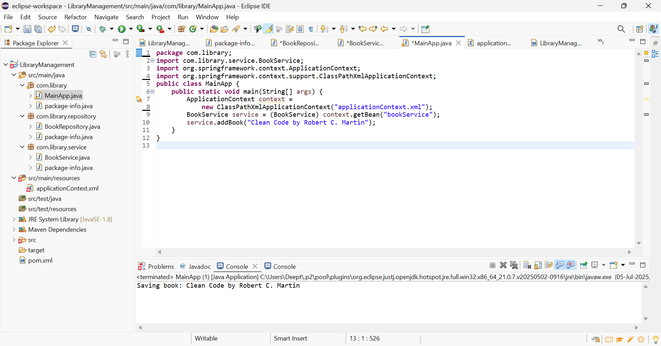

**Exercise 3: Implementing Logging with Spring AOP**

**Scenario:**

The library management application requires logging capabilities to track method execution times.

**Code:**

**pom.xml**

<project xmlns="http://maven.apache.org/POM/4.0.0"

xmlns:xsi="http://www.w3.org/2001/XMLSchema-instance"

xsi:schemaLocation="http://maven.apache.org/POM/4.0.0

http://maven.apache.org/xsd/maven-4.0.0.xsd">

<modelVersion>4.0.0</modelVersion>

<groupId>com.library</groupId>

<artifactId>LibraryManagement</artifactId>

<version>1.0-SNAPSHOT</version>

<properties>

<maven.compiler.source>1.8</maven.compiler.source>

<maven.compiler.target>1.8</maven.compiler.target>

</properties>

<dependencies>

<dependency>

<groupId>org.springframework</groupId>

<artifactId>spring-context</artifactId>

<version>5.3.36</version>

</dependency>

<dependency>

<groupId>org.springframework</groupId>

<artifactId>spring-aspects</artifactId>

<version>5.3.36</version>

</dependency>

<dependency>

<groupId>org.aspectj</groupId>

<artifactId>aspectjweaver</artifactId>

<version>1.9.21</version>

</dependency>

</dependencies>

<build>

<plugins>

<plugin>

<groupId>org.codehaus.mojo</groupId>

<artifactId>exec-maven-plugin</artifactId>

<version>3.1.0</version>

<configuration>

<mainClass>com.library.LibraryRunner</mainClass>

</configuration>

</plugin>

</plugins>

</build>

</project>

applicationContext.xml

<?xml version="1.0" encoding="UTF-8"?>

<beans xmlns="http://www.springframework.org/schema/beans"

xmlns:xsi="http://www.w3.org/2001/XMLSchema-instance"

xmlns:aop="http://www.springframework.org/schema/aop"

xsi:schemaLocation="

http://www.springframework.org/schema/beans

http://www.springframework.org/schema/beans/spring-beans.xsd

http://www.springframework.org/schema/aop

http://www.springframework.org/schema/aop/spring-aop.xsd">

<aop:aspectj-autoproxy />

<bean class="com.library.aspect.LoggingAspect" />

<bean id="libraryRepository" class="com.library.repository.LibraryRepository" />

<bean id="libraryService" class="com.library.service.LibraryService">

<property name="repository" ref="libraryRepository" />

</bean>

</beans>

**LoggingAspect.java**

package com.library.aspect;

import org.aspectj.lang.ProceedingJoinPoint;

import org.aspectj.lang.annotation.Around;

import org.aspectj.lang.annotation.Aspect;

@Aspect

public class LoggingAspect {

@Around("execution(* com.library.service.*.*(..))")

public Object logExecutionTime(ProceedingJoinPoint joinPoint) throws Throwable {

long start = System.currentTimeMillis();

Object result = joinPoint.proceed();

long end = System.currentTimeMillis();

System.out.println("Execution time of " + joinPoint.getSignature() + ": " + (end - start) + " ms");

return result;

}

}

**LibraryRepository.java**

package com.library.repository;

public class LibraryRepository {

public void save(String book) {

System.out.println("Saving book: " + book);

}

}

LibraryService.java

package com.library.service;

import com.library.repository.LibraryRepository;

public class LibraryService {

private LibraryRepository repository;

public void setRepository(LibraryRepository repository) {

this.repository = repository;

}

public void addBook(String book) {

repository.save(book);

}

}

**LibraryRunner.java**

package com.library;

import com.library.service.LibraryService;

import org.springframework.context.ApplicationContext;

import org.springframework.context.support.ClassPathXmlApplicationContext;

public class LibraryRunner {

public static void main(String[] args) {

ApplicationContext context = new ClassPathXmlApplicationContext("applicationContext.xml");

LibraryService service = (LibraryService) context.getBean("libraryService");

service.addBook("The Hobbit");

}

}

**Output:**

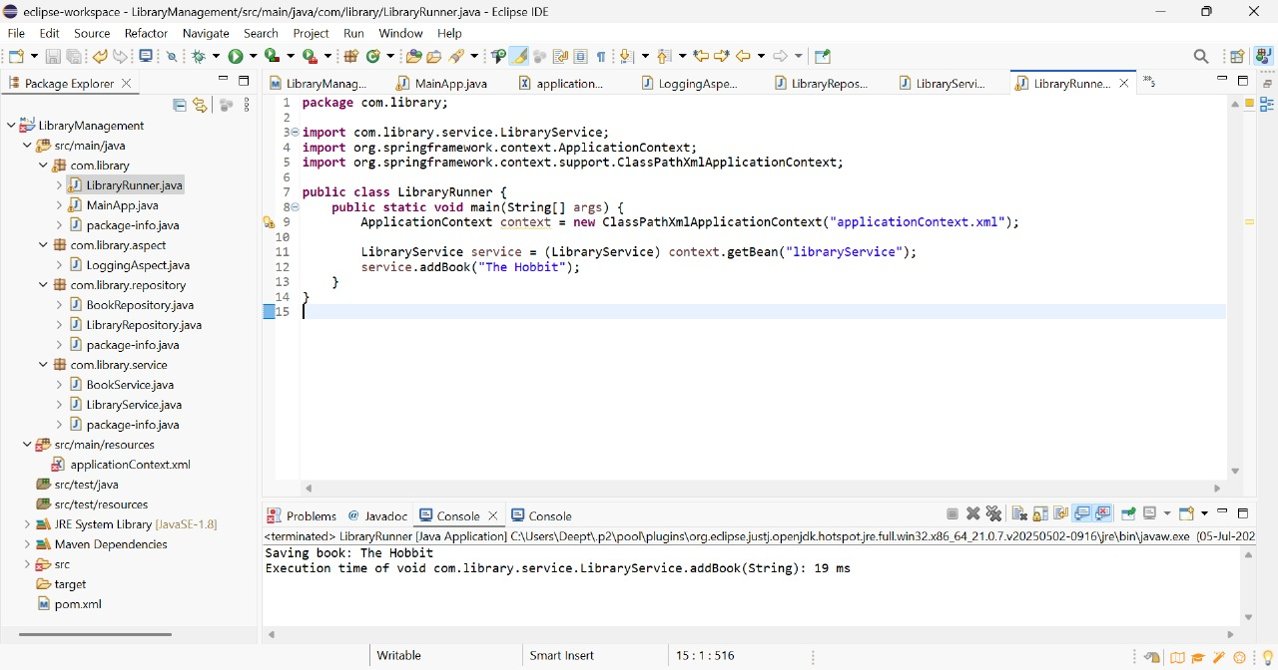

**Exercise 4: Creating and Configuring a Maven Project**

**Scenario:**

You need to set up a new Maven project for the library management application and add Spring dependencies.

**Code:**

**pom.xml**

<project xmlns="http://maven.apache.org/POM/4.0.0"

xmlns:xsi="http://www.w3.org/2001/XMLSchema-instance"

xsi:schemaLocation="

http://maven.apache.org/POM/4.0.0

http://maven.apache.org/xsd/maven-4.0.0.xsd">

<modelVersion>4.0.0</modelVersion>

<groupId>com.library</groupId>

<artifactId>LibraryManagement</artifactId>

<version>1.0-SNAPSHOT</version>

<packaging>war</packaging>

<properties>

<maven.compiler.source>1.8</maven.compiler.source>

<maven.compiler.target>1.8</maven.compiler.target>

</properties>

<dependencies>

<dependency>

<groupId>org.springframework</groupId>

<artifactId>spring-context</artifactId>

<version>5.3.36</version>

</dependency>

<dependency>

<groupId>org.springframework</groupId>

<artifactId>spring-aspects</artifactId>

<version>5.3.36</version>

</dependency>

<dependency>

<groupId>org.springframework</groupId>

<artifactId>spring-webmvc</artifactId>

<version>5.3.36</version>

</dependency>

<dependency>

<groupId>org.aspectj</groupId>

<artifactId>aspectjweaver</artifactId>

<version>1.9.21</version>

</dependency>

<dependency>

<groupId>jakarta.servlet</groupId>

<artifactId>jakarta.servlet-api</artifactId>

<version>5.0.0</version>

<scope>provided</scope>

</dependency>

</dependencies>

<build>

<plugins>

<plugin>

<groupId>org.apache.maven.plugins</groupId>

<artifactId>maven-compiler-plugin</artifactId>

<version>3.11.0</version>

<configuration>

<source>1.8</source>

<target>1.8</target>

</configuration>

</plugin>

<plugin>

<groupId>org.apache.maven.plugins</groupId>

<artifactId>maven-war-plugin</artifactId>

<version>3.4.0</version>

</plugin>

</plugins>

</build>

</project>

**LibraryRepository.java**

package com.library.repository;

public class LibraryRepository {

public void saveBook(String title) {

System.out.println("Saving book: " + title);

}

}

**LibraryService.java**

package com.library.service;

import com.library.repository.LibraryRepository;

public class LibraryService {

private LibraryRepository repository;

public void setRepository(LibraryRepository repository) {

this.repository = repository;

}

public void addBook(String title) {

repository.saveBook(title);

}

}

**LoggingAspect.java**

package com.library.aspect;

import org.aspectj.lang.ProceedingJoinPoint;

import org.aspectj.lang.annotation.*;

import org.springframework.stereotype.Component;

@Aspect

@Component

public class LoggingAspect {

@Around("execution(* com.library.service.*.*(..))")

public Object logExecutionTime(ProceedingJoinPoint joinPoint) throws Throwable {

long start = System.currentTimeMillis();

Object result = joinPoint.proceed();

long duration = System.currentTimeMillis() - start;

System.out.println("Execution time of " + joinPoint.getSignature() + ": " + duration + " ms");

return result;

}

}

**LibraryController.java**

package com.library.controller;

import com.library.service.LibraryService;

import org.springframework.beans.factory.annotation.Autowired;

import org.springframework.stereotype.Controller;

import org.springframework.web.bind.annotation.*;

@Controller

public class LibraryController {

@Autowired

private LibraryService libraryService;

@GetMapping("/form")

@ResponseBody

public String form() {

return "<form action='/addBook' method='post'>" +

"Book Title: <input name='title'/>" +

"<input type='submit'/>" +

"</form>";

}

@PostMapping("/addBook")

@ResponseBody

public String addBook(@RequestParam("title") String title) {

libraryService.addBook(title);

return "Book added: " + title;

}

}

**LibraryRunner.java**

package com.library;

import com.library.service.LibraryService;

import org.springframework.context.ApplicationContext;

import org.springframework.context.support.ClassPathXmlApplicationContext;

public class LibraryRunner {

public static void main(String[] args) {

ApplicationContext context = new ClassPathXmlApplicationContext("applicationContext.xml");

LibraryService service = context.getBean("libraryService", LibraryService.class);

service.addBook("The Hobbit");

}

}

applicationContext.xml

<?xml version="1.0" encoding="UTF-8"?>

<beans xmlns="http://www.springframework.org/schema/beans"

xmlns:context="http://www.springframework.org/schema/context"

xmlns:aop="http://www.springframework.org/schema/aop"

xmlns:xsi="http://www.w3.org/2001/XMLSchema-instance"

xsi:schemaLocation="

http://www.springframework.org/schema/beans

http://www.springframework.org/schema/beans/spring-beans.xsd

http://www.springframework.org/schema/context

http://www.springframework.org/schema/context/spring-context.xsd

http://www.springframework.org/schema/aop

http://www.springframework.org/schema/aop/spring-aop.xsd">

<context:component-scan base-package="com.library" />

<aop:aspectj-autoproxy />

<bean id="libraryRepository" class="com.library.repository.LibraryRepository" />

<bean id="libraryService" class="com.library.service.LibraryService">

<property name="repository" ref="libraryRepository" />

</bean>

</beans>

**web.xml**

<web-app xmlns="http://jakarta.ee/xml/ns/jakartaee"

xmlns:xsi="http://www.w3.org/2001/XMLSchema-instance"

xsi:schemaLocation="http://jakarta.ee/xml/ns/jakartaee

http://jakarta.ee/xml/ns/jakartaee/web-app_5_0.xsd"

version="5.0">

<servlet>

<servlet-name>spring</servlet-name>

<servlet-class>org.springframework.web.servlet.DispatcherServlet</servlet-class>

<init-param>

<param-name>contextConfigLocation</param-name>

<param-value>/WEB-INF/applicationContext.xml</param-value>

</init-param>

<load-on-startup>1</load-on-startup>

</servlet>

<servlet-mapping>

<servlet-name>spring</servlet-name>

<url-pattern>/</url-pattern>

</servlet-mapping>

</web-app>

**Output:**

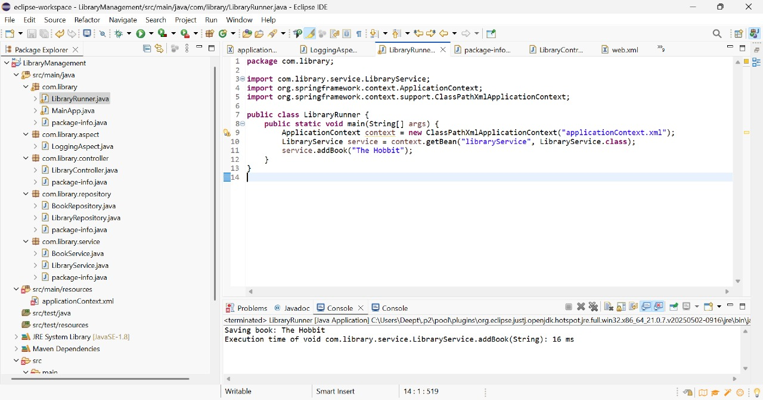

**Exercise 5: Configuring the Spring IoC Container**

**Scenario:**

The library management application requires a central configuration for beans and dependencies.

**Code:**

**applicationContext.xml**

<?xml version="1.0" encoding="UTF-8"?>

<beans xmlns="http://www.springframework.org/schema/beans"

xmlns:xsi="http://www.w3.org/2001/XMLSchema-instance"

xsi:schemaLocation="

http://www.springframework.org/schema/beans

http://www.springframework.org/schema/beans/spring-beans.xsd">

<bean id="libraryRepository" class="com.library.repository.LibraryRepository" />

<bean id="libraryService" class="com.library.service.LibraryService">

<property name="repository" ref="libraryRepository"/>

</bean>

</beans>

**LibraryService.java**

package com.library.service;

import com.library.repository.LibraryRepository;

public class LibraryService {

private LibraryRepository repository;

public void setRepository(LibraryRepository repository) {

this.repository = repository;

}

public void addBook(String title) {

repository.saveBook(title);

}

}

**LibraryRunner.java**

package com.library;

import com.library.service.LibraryService;

import org.springframework.context.ApplicationContext;

import org.springframework.context.support.ClassPathXmlApplicationContext;

public class LibraryRunner {

public static void main(String[] args) {

ApplicationContext context = new ClassPathXmlApplicationContext("applicationContext.xml");

LibraryService service = context.getBean("libraryService", LibraryService.class);

service.addBook("The Alchemist");

}

}

**LibraryRepository.java**

package com.library.repository;

public class LibraryRepository {

public void saveBook(String title) {

System.out.println("Saving book: " + title);

}

}

**Output:**

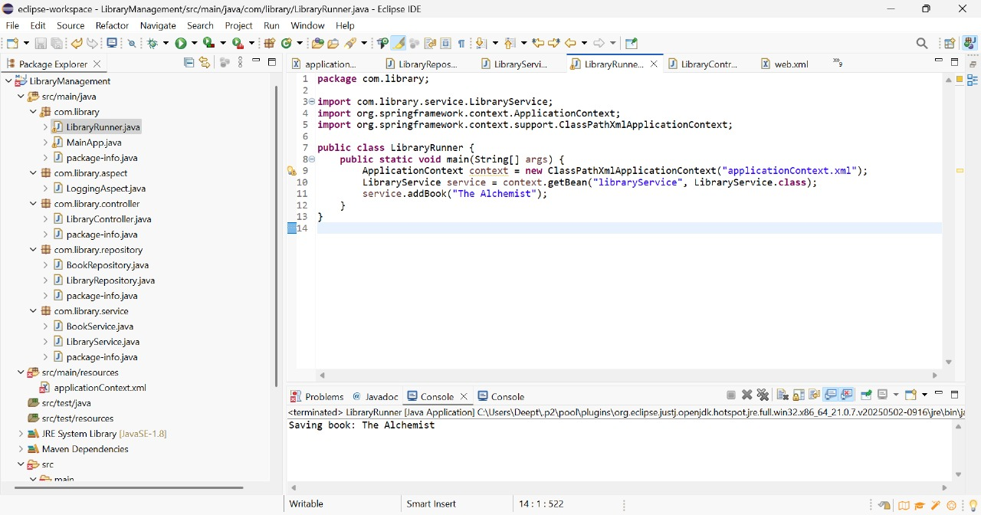

**Exercise 6: Configuring Beans with Annotations**

**Scenario:**

You need to simplify the configuration of beans in the library management application using annotations.

**Code:**

**applicationContext.xml**

<?xml version="1.0" encoding="UTF-8"?>

<beans xmlns="http://www.springframework.org/schema/beans"

xmlns:context="http://www.springframework.org/schema/context"

xmlns:xsi="http://www.w3.org/2001/XMLSchema-instance"

xsi:schemaLocation="

http://www.springframework.org/schema/beans

http://www.springframework.org/schema/beans/spring-beans.xsd

http://www.springframework.org/schema/context

http://www.springframework.org/schema/context/spring-context.xsd">

<context:component-scan base-package="com.library" />

</beans>

**LibraryService.java**

package com.library.service;

import com.library.repository.LibraryRepository;

import org.springframework.beans.factory.annotation.Autowired;

import org.springframework.stereotype.Service;

@Service

public class LibraryService {

@Autowired

private LibraryRepository repository;

public void addBook(String title) {

repository.saveBook(title);

}

}

**LibraryRepository.java**

package com.library.repository;

import org.springframework.stereotype.Repository;

@Repository

public class LibraryRepository {

public void saveBook(String title) {

System.out.println("Saving book: " + title);

}

}

**LibraryRunner.java**

package com.library;

import com.library.service.LibraryService;

import org.springframework.context.ApplicationContext;

import org.springframework.context.support.ClassPathXmlApplicationContext;

public class LibraryRunner {

public static void main(String[] args) {

ApplicationContext context = new ClassPathXmlApplicationContext("applicationContext.xml");

LibraryService service = context.getBean(LibraryService.class);

service.addBook("To Kill a Mockingbird");

**}**

**Output:**

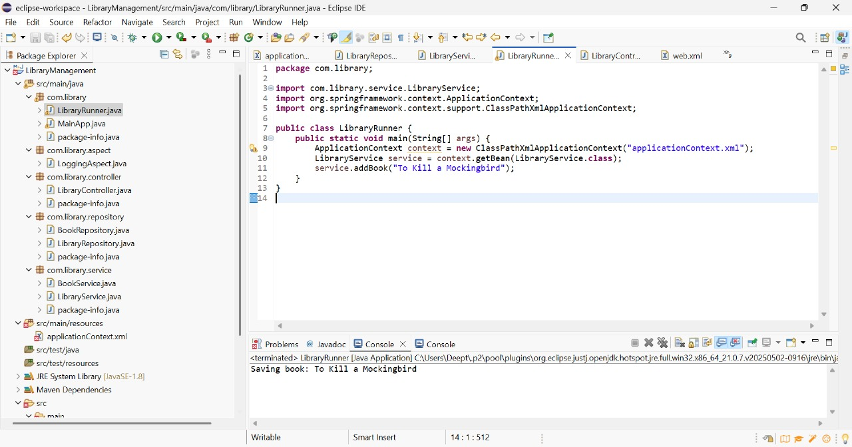

**Exercise 7: Implementing Constructor and Setter Injection**

**Scenario:**

The library management application requires both constructor and setter injection for better control over bean initialization.

**Code:**

**applicationContext.xml**

<?xml version="1.0" encoding="UTF-8"?>

<beans xmlns="http://www.springframework.org/schema/beans"

xmlns:xsi="http://www.w3.org/2001/XMLSchema-instance"

xsi:schemaLocation="

http://www.springframework.org/schema/beans

http://www.springframework.org/schema/beans/spring-beans.xsd">

<bean id="libraryRepository" class="com.library.repository.LibraryRepository" />

<bean id="libraryService" class="com.library.service.LibraryService">

<constructor-arg value="Central Library"/>

<property name="repository" ref="libraryRepository"/>

</bean>

</beans>

**LibraryService.java**

package com.library.service;

import com.library.repository.LibraryRepository;

public class LibraryService {

private String libraryName;

private LibraryRepository repository;

public LibraryService(String libraryName) {

this.libraryName = libraryName;

}

public void setRepository(LibraryRepository repository) {

this.repository = repository;

}

public void addBook(String title) {

System.out.println("Library: " + libraryName);

repository.saveBook(title);

}

}

**LibraryRunner.java**

package com.library;

import com.library.service.LibraryService;

import org.springframework.context.ApplicationContext;

import org.springframework.context.support.ClassPathXmlApplicationContext;

public class LibraryRunner {

public static void main(String[] args) {

ApplicationContext context = new ClassPathXmlApplicationContext("applicationContext.xml");

LibraryService service = context.getBean("libraryService", LibraryService.class);

service.addBook("1984");

}

}

**Output:**

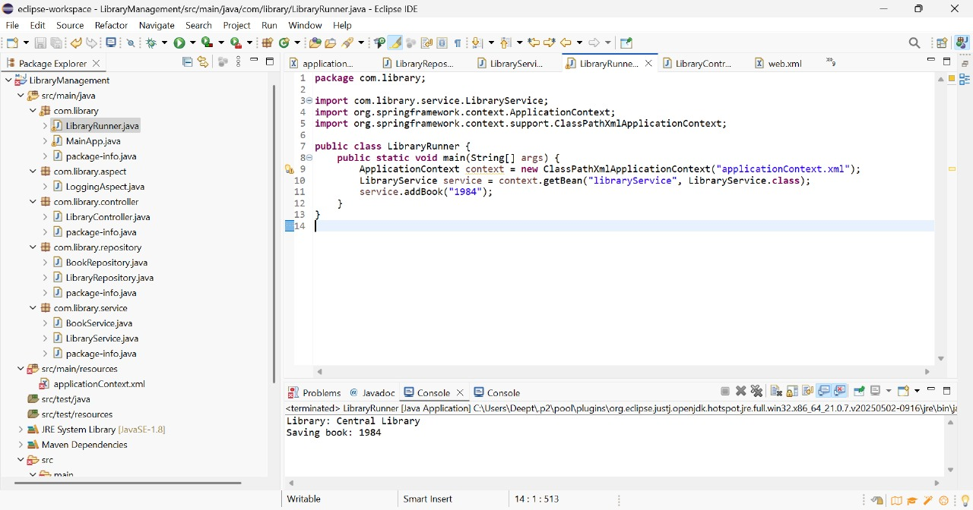

**Exercise 8: Implementing Basic AOP with Spring**

**Scenario:**

The library management application requires basic AOP functionality to separate cross-cutting concerns like logging and transaction management.

**Code:**

**LoggingAspect.java**

package com.library.aspect;

import org.aspectj.lang.JoinPoint;

import org.aspectj.lang.annotation.*;

import org.springframework.stereotype.Component;

@Aspect

@Component

public class LoggingAspect {

@Before("execution(* com.library.service.*.*(..))")

public void logBefore(JoinPoint joinPoint) {

System.out.println("[LOG BEFORE] Executing: " + joinPoint.getSignature());

}

@After("execution(* com.library.service.*.*(..))")

public void logAfter(JoinPoint joinPoint) {

System.out.println("[LOG AFTER] Executed: " + joinPoint.getSignature());

}

}

**applicationContext.xml**

<?xml version="1.0" encoding="UTF-8"?>

<beans xmlns="http://www.springframework.org/schema/beans"

xmlns:context="http://www.springframework.org/schema/context"

xmlns:aop="http://www.springframework.org/schema/aop"

xmlns:xsi="http://www.w3.org/2001/XMLSchema-instance"

xsi:schemaLocation="

http://www.springframework.org/schema/beans

http://www.springframework.org/schema/beans/spring-beans.xsd

http://www.springframework.org/schema/context

http://www.springframework.org/schema/context/spring-context.xsd

http://www.springframework.org/schema/aop

http://www.springframework.org/schema/aop/spring-aop.xsd">

<context:component-scan base-package="com.library" />

<aop:aspectj-autoproxy />

</beans>

**LibraryService.java**

package com.library.service;

import com.library.repository.LibraryRepository;

import org.springframework.beans.factory.annotation.Autowired;

import org.springframework.stereotype.Service;

@Service

public class LibraryService {

@Autowired

private LibraryRepository repository;

public void addBook(String title) {

System.out.println("Adding book: " + title);

repository.saveBook(title);

}

}

**LibraryRepository.java**

package com.library.repository;

import org.springframework.stereotype.Repository;

@Repository

public class LibraryRepository {

public void saveBook(String title) {

System.out.println("Saving book: " + title);

}

}

**LibraryRunner.java**

package com.library;

import com.library.service.LibraryService;

import org.springframework.context.ApplicationContext;

import org.springframework.context.support.ClassPathXmlApplicationContext;

public class LibraryRunner {

public static void main(String[] args) {

ApplicationContext context = new ClassPathXmlApplicationContext("applicationContext.xml");

LibraryService service = context.getBean(LibraryService.class);

service.addBook("Pride and Prejudice");

}

}

**Output:**

